Report & Form Specification

YFF001 – Nota Retur

VERSION: 1.0
LAST UPDATED: 14.12.2018

DOCUMENT CONTROL:

REVISION HISTORY:

Version # | Date Modified | Modified By | Brief Description of Change
V.01 | 14.12.2018 | Aditya R

APPROVALS:

Author | Aditya Rahadian | Date Created: | 14.12.2018
Functional Team Lead | Aditya Rahadian | Signature and Date Approved:
Business Process Owner | Molindo Group | Signature and Date Approved:
Technical Team Lead | I Wayan Marta Sudhyana | Signature and Date Approved:
Project Manager | Devi Andrianto | Signature and Date Approved:

TABLE OF CONTENTS:

I. INTRODUCTION 2
A. Purpose of the document 2
B. Request Overview 2
II. OVERVIEW 2
A. Business Driver 2
B. Process overview 2
III. FUNCTIONAL DETAILS 2
A. Detail Processing Logic 2
B. Selection Screen 2
C. Report/Form Layout 2
D. Special characteristics 2
E. Exception Handling Rules 2
F. Special Requirements 2
G. Test Specification 2
1. Functional Test Scenarios 2
2. Test Data & Other Needs 2
3. Test System & Environment 2
H. Security/Authorization Requirements 2
IV. TECHNICAL DETAILS 2
A. Object Attributes 2
B. Data Dictionary Used 2
C. Custom Data Dictionary 2
D. Processing Details 2
E. Transaction/Batch Job that will access 2
F. Sort Options 2
G. Notes 2

INTRODUCTION

Purpose of the document
The purpose of this document is to document any SAP code modification or additional processing logic requirements to further enhance the standard SAP delivered functionality. This document once approved by the appropriate authorities as mentioned in section “Document Control” forms the basis of Technical specification and the development work by the Development team.

Request Overview
1. Scenario ID : -
2. Scenario Title : -
3. Process ID : -
4. Process Title : -
5. Name of Report/Form : Nota Retur
6. Short Description : for print out Nota Retur to vendor

7. Type: ABAP Report Form Query
Other_________________
8. Tools used ABAP List/Program ALV Smartform
SAP Script Other_________________
9. Data latency: Batch On-demand
10. Frequency: Annually Quarterly Monthly Weekly
Daily Other_________________
11. Requesting Team : ____________________
12. Systems Impacted: ECC CRM SRM BW SEM
Other____________
13. Modules Impacted: PS SD FI CO PP MM WM PM
SM QM HR Others____________
14. Complexity High Medium Low
15. Paper Size A4 Letter Other, __________
16. Paper Orientation Portrait Landscape
17. Printer Type LaserJet /DeskJet Dot Matrix
18. Spec Created on : 14.12.2018
19. Date required by : 14.12.2018
20. Created by : Aditya Rahadian ________________ Phone:
21. Functional Analyst : Aditya Rahadian ________________ Phone:
22. Technical Analyst : Evan Christiawan________________ Phone:
23. Business Owner : Molindo Group__________________ Phone:

OVERVIEW

Business Driver
Invoice is needed when for invoicing to customer

Process overview
<Attach process flow chart and system architecture showing all the concerned systems if required>

FUNCTIONAL DETAILS

Detail Processing Logic
- Print Nota Retur yang berasal dari transaksi MIRO di MM module

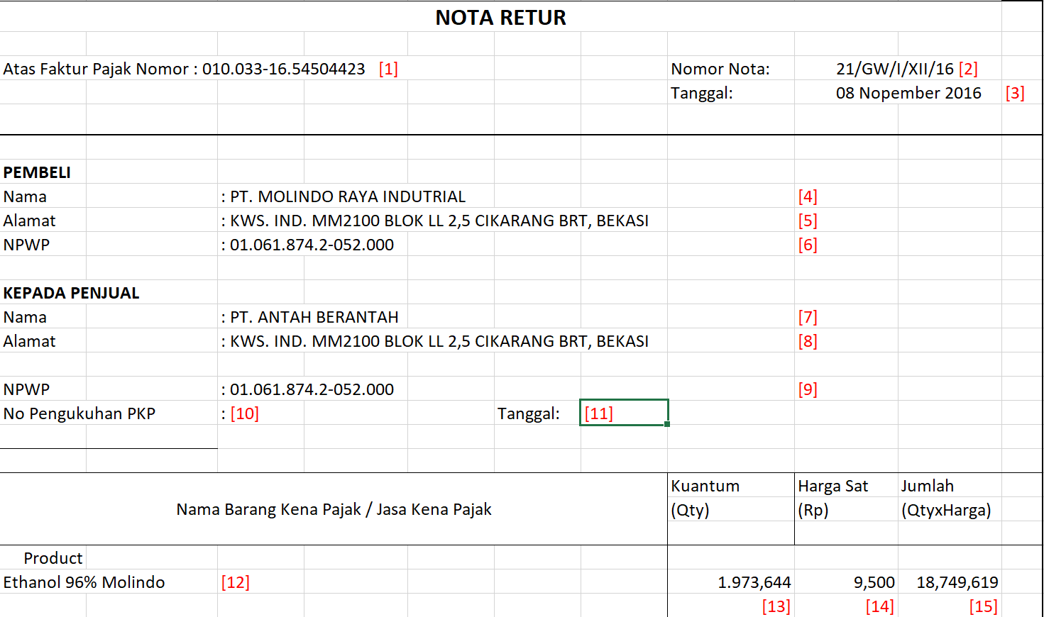
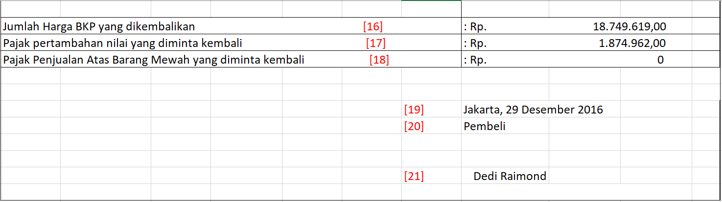

Dimana
BKPF-BUKRS=S_BUKRS
BKPF-BELNR=S_BELNR
BKPF-GJAHR=S_GJAHR

No | Title | Table-Field | Remarks
1 | Atas Faktur Pajak Nomor : | Atas Faktur Pajak Nomor= BKPF-BKTXT  Logic  Ambil BKTXT dari BKPF  Dimana  BUKRS=S_BUKRS  BELNR=S_BELNR  GJAHR=S_GJAHR
2 | Nomor Nota : | Nomor Nota =BSEG-ZUONR  Logic  Ambil ZUONR dari BSEG  Dimana  BUKRS=S_BUKRS  BELNR=S_BELNR  GJAHR=S_GJAHR  RLDNR=”0L”  KOART=”K”
3 | Tanggal : | ?
4 | Nama (Pembeli) : | Nama(Pembeli) = ADRC-MC_NAME1  Logic  Ambil ADRNR dari T001  Dimana  BUKRS=S_BUKRS  Ambil MC_NAME1 dari ADRC  Dimana  ADDRNUMBER =T001-ADRNR
5 | Alamat(Pembeli) | Alamat(Pembeli) = ADRC-MC_STREET,MC_CITY1  Logic  Ambil ADRNR dari T001  Dimana  BUKRS=S_BUKRS  Ambil MC_STREET, MC_CITY1 dari ADRC  Dimana  ADDRNUMBER =T001-ADRNR
6 | NPWP(Pembeli) | NPWP(Pembeli) = T001Z- PAVAL (XX.XXX.XXX.X-XXX.XXX)  Logic  Ambil PAVAL dari T001Z  Dimana  BUKRS=S_BUKRS  PARTY=”IDNPWP”
7 | Nama (Penjual) | Nama(Penjual) = ADRC-MC_NAME1  Logic  Ambil LIFNR dari BSEG  Dimana  BUKRS=S_BUKRS  BELNR=S_BELNR  GJAHR=S_GJAHR  RLDNR=”0L”  KOART=”K”  Ambil ADDRNUMBER dari BUT020  Dimana  PARTNER=BSEG-LIFNR  Ambil MC_NAME1 dari ADRC  Dimana  ADDRNUMBER =BUT020- ADDRNUMBER
8 | Alamat(Penjual) | Alamat(Penjual) = ADRC-MC_STREET,MC_CITY1  Logic  Ambil LIFNR dari BSEG  Dimana  BUKRS=S_BUKRS  BELNR=S_BELNR  GJAHR=S_GJAHR  RLDNR=”0L”  KOART=”K”  Ambil ADDRNUMBER dari BUT020  Dimana  PARTNER=BSEG-LIFNR  Ambil ADRC-MC_STREET,MC_CITY1dari ADRC  dimana  ADDRNUMBER =BUT020- ADDRNUMBER
9 | NPWP (Penjual) | NPWP(Penjual) = DFKKBPTAXNUM- TAXNUM (XX.XXX.XXX.X-XXX.XXX)  Logic  Ambil LIFNR dari BSEG  Dimana  BUKRS=S_BUKRS  BELNR=S_BELNR  GJAHR=S_GJAHR  RLDNR=”0L”  KOART=”K”  Logic  Ambil TAXNUM dari DFKKBPTAXNUM  Dimana  DFKKBPTAXNUM - PARTNER =BSEG- LIFNR  DFKKBPTAXNUM - TAXTYPE =”ID1”
10 | No Pengukuhan PKP : | ?
11 | Tanggal : | ?
12 | Nama Barang Kena Pajak / Jasa Kena Pajak : | Nama Barang Kena Pajak / Jasa Kena Pajak : EKPO- TXZ01  Logic  Ambil EBELN, EBELP,dari BSEG  Dimana  BUKRS=S_BUKRS  BELNR=S_BELNR  GJAHR=S_GJAHR  RLDNR=”0L”  KTOSL=”WRX”  Ambil TXZ01 dari EKPO  Dimana  EBELN= BSEG-EBELN  EBELP=BSEG-EBELP
13 | Kuantum (Qty) | Kuantum (Qty) =BSEG-MENGE  Ambil MENGE dari BSEG  Dimana  BUKRS=S_BUKRS  BELNR=S_BELNR  GJAHR=S_GJAHR  RLDNR=”0L”  KTOSL=”WRX”
14 | Harga Sat  (Rp) | Jumlah /Kuantum
15 | Jumlah  (QtyXHarga) | Jumlah (QtyXHarga)=BSEG-PSWBT  Ambil PSWBT dari BSEG  Dimana  BUKRS=S_BUKRS  BELNR=S_BELNR  GJAHR=S_GJAHR  RLDNR=”0L”  KTOSL=”WRX”
16 | Jumlah Harga BKP yang dikembalikan : | Jumlah Harga BKP yang dikembalikan = Jumlah (QtyXHarga)
17 | Pajak pertambahan nilai yang diminta kembali | Pajak pertambahan nilai yang diminta kembali=BSEG-PSWBT  Ambil PSWBT dari BSEG  Dimana  BUKRS=S_BUKRS  BELNR=S_BELNR  GJAHR=S_GJAHR  RLDNR=”0L”  KTOSL=”VST”
18 | Pajak Penjualan Atas Barang Mewah yang diminta kembali : | ? Kosong saja, krn tidak ada
19 | Kota, Tanggal | Kota, Tanggal = ADRC -MC_CITY1, BUDAT  Logic  Ambil LIFNR,BUDAT dari BSEG  Dimana  BUKRS=S_BUKRS  BELNR=S_BELNR  GJAHR=S_GJAHR  RLDNR=”0L”  KOART=”K”  Ambil ADDRNUMBER dari BUT020  Dimana  PARTNER=BSEG-LIFNR  Ambil ADRC-MC_STREET,MC_CITY1dari ADRC  dimana  ADDRNUMBER =BUT020- ADDRNUMBER
20 | Pembeli | “Pembeli”
21 | Nama Penanda Tangan | Y table?

Selection Screen
<Describe the selection screen if used. Specify the fields for the selection and what checks need to be done after the user has entered his or her criteria.- Required >

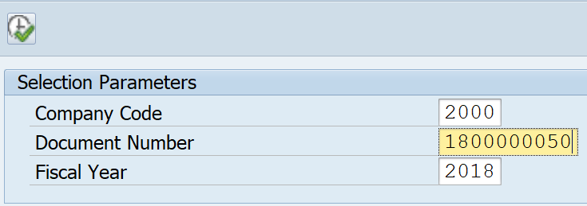
No | Title | Table-Field | Remarks
1 | Company Code | S_BUKRS
2 | Document Number | S_BELNR
3 | Fiscal Year | S_GJAHR

Report/Form Layout
<If a separate file has been created to define the output or form, embed in the document or mention the network path and filename here - Required >

Special characteristics
< Sorting, grouping, where total or subtotals should occur, if any, drilldown, etc.>

Exception Handling Rules
<Specify instructions to be followed when errors occur, or any processing outside the normal process flow.>

Special Requirements
<Provide any special requirements related to this development effort such as language translations, configurability or personalization allowed, etc.>

Test Specification
<This portion of the document is used to plan the unit testing. It includes items such as defining the test participants, the test environment, the schedule, and scope of the testing event.>

Functional Test Scenarios
<Document test scenarios to test all of the functional requirements. Include a test scenario for each different business scenario that may occur.>

ID | Test Scenario | Expected Results | Comments
1
2
3

Test Data & Other Needs
<If any, specify test data set-up & refresh needs, volume of data, timeliness of data, etc.>

Test System & Environment
<Identify test system and client.>

Test System:
Client:

Security/Authorization Requirements
<Provide any special authorization checking or data security provisions required.>

TECHNICAL DETAILS

Object Attributes

- Original Program Name : YMOLFF003
- Original Form Name : YMOLX_NOTA_RET
- Report/Form Program Name :
- SAPScript Form Name :
- Smart Form Name : YMOLX_NOTA_RET
- Output Type :
- Custom Style Name : YMOLX_STD_STYLE
- Custom Page Format :
- Correspondence Type :
- Transaction Code : YMOLFF003
- Package (Dev. Class) : YMOL
- Menu Path :
- Default Printer :
- Created / Developed By : Evan Christiawan

SAP Dictionary Used

Table Name | Table Description | Notes
BKPF | Accounting Document Header
BSEG | Accounting Document Segment
EKPO | Purchasing Document Item

Custom Data Dictionary
Structure Name | Table Description | Notes
YMOLXS036 | Nota Retur Header
YMOLXS037 | Nota Retur Item

Structure Name | YMOLXS036 | Nota Retur Header
Field Name | Data Element | Length | Decimal | Description
NO_FP | PAVAL | 48 | 0 | Parameter value
NO_NOTA | AD_MC_NAME | 25 | 0 | Name (Field NAME1) in Uppercase for Search Help
DATE_NOTA | AD_MC_STRT | 25 | 0 | Street Name in Uppercase for Search Help
NAME_B | AD_MC_CITY | 25 | 0 | City name in Uppercase for Search Help
STREET_B | PAVAL | 48 | 0 | Parameter value
CITY_B | CHAR30 | 30 | 0 | 30 Characters
NPWP_B | DATUM | 8 | 0 | Date
NAME_S | AD_MC_CITY | 25 | 0 | City name in Uppercase for Search Help
STREET_S | DATUM | 8 | 0 | Date
CITY_S | PSWBT | 13 | 2 | Amount for Updating in General Ledger
NPWP_S | WAERK | 5 | 0 | SD document currency
NO_PKP | PAVAL | 48 | 0 | Parameter value
DATE_PKP | AD_MC_NAME | 25 | 0 | Name (Field NAME1) in Uppercase for Search Help
CITY_SIGN | AD_MC_STRT | 25 | 0 | Street Name in Uppercase for Search Help
DATE_SIGN | AD_MC_CITY | 25 | 0 | City name in Uppercase for Search Help
PPN_RETUR | PAVAL | 48 | 0 | Parameter value
CURRENCY | CHAR30 | 30 | 0 | 30 Characters

Structure Name | YMOLXS037 | Nota Retur Item [Barang Kena Pajak/Jasa Kena Pajak]
Field Name | Data Element | Length | Decimal | Description
NAME_ITEM | TXZ01 | 40 | 0 | Short Text
KUANTUM | MENGE_D | 13 | 3 | Quantity
BASE_UNIT | MEINS | 3 | 0 | Base Unit of Measure
CURRENCY | WAERK | 5 | 0 | SD document currency
PRICE | PSWBT | 13 | 2 | Amount for Updating in General Ledger
AMOUNT | PSWBT | 13 | 2 | Amount for Updating in General Ledger

Processing Details

Selection Screen
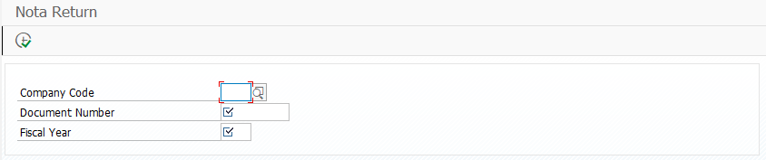

Process Flow
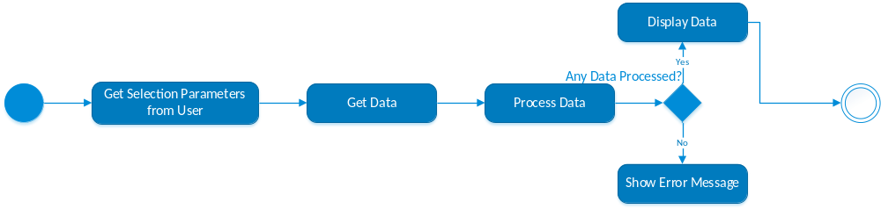

Subroutines

f_get_data
Routine yang berfungsi untuk mengambil data – data yang dibutuhkan untuk report dengan mapping sebagai berikut:

Source Data | Target Variable / Table | Note
T001T, ADRC | wa_hdr-name_b  wa_hdr-street_b  wa_hdr-city_b | Get Buyer's Identity and address according the Company Code
T001Z | wa_hdr-npwp_b | Get Buyer's NPWP
BKPF, BSEG, EKPO | T_BKPFBSEG | Get Nota Retur Data

f_set_data
Routine ini digunakan untuk mengolah data yang sudah diambil dari subroutine f_get_data, data tersebut akan di populate menjadi structure dan internal table bernama wa_hdr sebagai header dan t_itm sebagai table item yang nanti nya akan digunakana untuk printout smartform.

f_display_smartforms
Routine ini digunakan untuk menyiapkan smartform dan menampilkan bedasarkan data wa_hdr dan table t_itm yang sudah disiapkan di f_set_data. Bila tidak ada data, error akan ditampilkan.

Smartform Printout
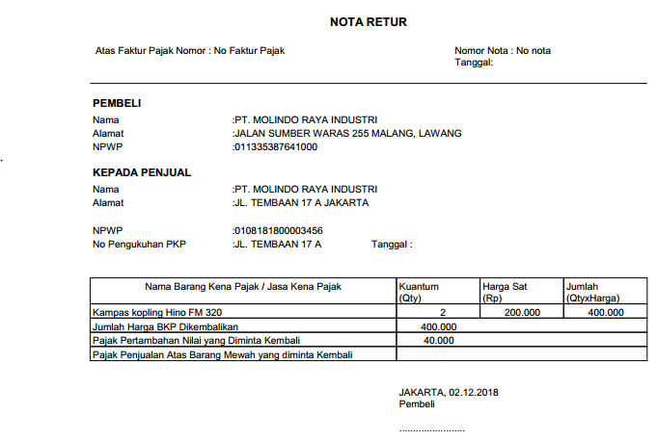

Transaction/Batch Job that will access
...

Sort Options
- ...

Notes

